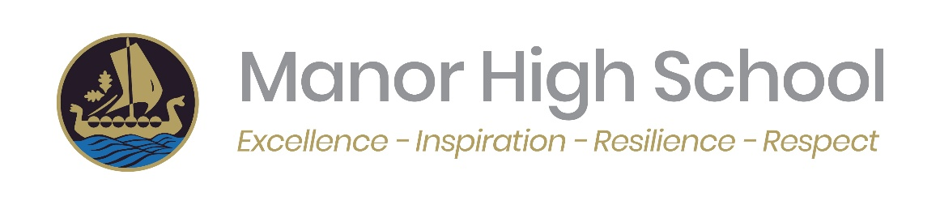
Copse Close, Oadby, Leicestershire LE2 4FU
Telephone: 0116 271 4941
admin@manorhigh.leics.sch.uk
www.manorhigh.leics.sch.uk
Headteacher: Mr S Greiff

Dear Parents and Carers,

At Manor High School, pupils’ personal wellbeing and development are supported through our Personal, Social, Health and Economic (PSHE) education programme. PSHE helps young people develop the knowledge, understanding and skills needed to live safe, healthy and fulfilling lives and to prepare for adulthood. All lessons are delivered in a safe and supportive environment and reflect our school ethos and values.

As part of PSHE, pupils receive Relationships and Sex Education (RSE), which is a statutory element of the curriculum. RSE supports pupils’ personal, social and emotional development by providing accurate, age-appropriate information about relationships, wellbeing, and staying safe. Lessons are taught using professional, evidence-based resources and are inclusive, respectful and non-judgemental.

PSHE and RSE follow a spiral curriculum, with topics revisited and developed over time in line with pupils’ age. Parents and carers are encouraged to engage with their child’s learning and discuss topics at home where appropriate. Further information about our PSHE and RSE curriculum is available on the school website:
https://www.manorhigh.leics.sch.uk/curriculum-learning/pshe/

Right to Withdraw
Parents and carers may request that their child is withdrawn from the non-statutory elements of Sex Education within RSE. There is no right to withdraw from Relationships Education, Health Education, or Science curriculum content.
Requests must be made in writing to the Headteacher via PSHE@manorhigh.leics.sch.uk by 6 February 2026, including the pupil’s name, year group and reason for withdrawal. Each request will be discussed individually in line with statutory guidance.
Please note that pupils have the legal right to opt into Sex Education from three terms before their 16th birthday, even if previously withdrawn.

Working in Partnership
We are committed to working in partnership with parents and carers to support pupils’ wellbeing. Any questions about our PSHE or RSE curriculum should be sent to PSHE@manorhigh.leics.sch.uk and will be responded to by the PSHE team.

Thank you for your continued support.

Yours sincerely,
Mr J. Clothier
PSHE Curriculum Lead

